Maria plays college basketball and wants to go pro. Each season she maintains a record of her play. She tabulates the number of times she breaks her season record for *most points* and *least points* in a game. Points scored in the first game establish her record for the season, and she begins counting from there.

**Example**

Scores are in the same order as the games played. She tabulates her results as follows:

Count

Game Score Minimum Maximum Min Max

0 12 12 12 0 0

1 24 12 24 0 1

2 10 10 24 1 1

3 24 10 24 1 1

Given the scores for a season, determine the number of times Maria breaks her records for *most* and *least* points scored during the season.

**Function Description**

Complete the *breakingRecords* function in the editor below.

breakingRecords has the following parameter(s):

* *int scores[n]:* points scored per game

**Returns**

* *int[2]:* An array with the numbers of times she broke her records. Index  is for breaking *most points* records, and index  is for breaking *least points* records.

**Input Format**

The first line contains an integer , the number of games.  
The second line contains  space-separated integers describing the respective values of .

**Constraints**

**Sample Input 0**

9

10 5 20 20 4 5 2 25 1

**Sample Output 0**

2 4

**Explanation 0**

The diagram below depicts the number of times Maria broke her best and worst records throughout the season:

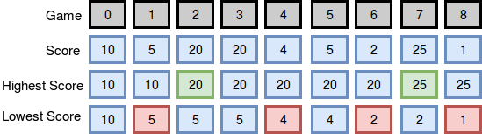

She broke her best record twice (after games  and ) and her worst record four times (after games , , , and ), so we print 2 4 as our answer. Note that she *did not* break her record for best score during game , as her score during that game was *not* strictly greater than her best record at the time.

**Sample Input 1**

10

3 4 21 36 10 28 35 5 24 42

**Sample Output 1**

4 0

**Explanation 1**

The diagram below depicts the number of times Maria broke her best and worst records throughout the season:

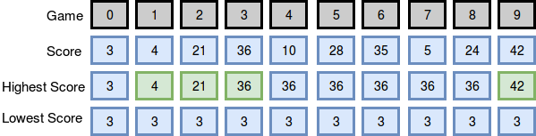

She broke her best record four times (after games , , , and ) and her worst record zero times (no score during the season was lower than the one she earned during her first game), so we print 4 0 as our answer.